NEWS RELEASE
SLATE HOSPLITALITY GROUP, LLC CELEBRATES THE OPENING OF THE COBBLESTONE HOTEL & SUITES IN LAMAR, COLORADO.
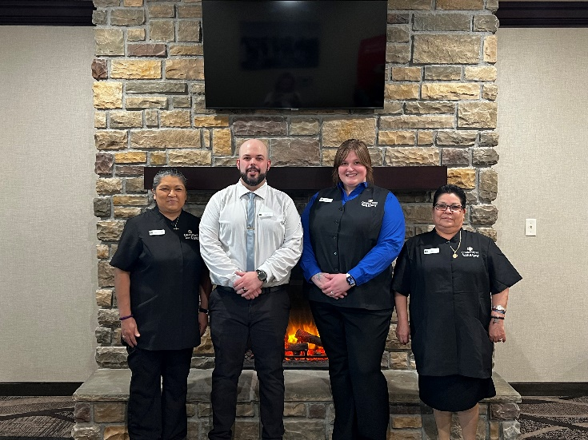
March 7, 2023 – Neenah, WI – Slate Hospitality Group (“SHG”) announces the opening of the Cobblestone Hotel & Suites - Lamar. The addition of this location marks SHG’s ninth managed property in the great state of Colorado.
The Cobblestone Hotel & Suites is established at 1215 North Main Street in the city of Lamar. This 3-floor hotel will consist of 54 elegantly designed guestrooms equipped with premium amenities and services to ensure the comfort and convenience of the modern traveler.
This hotel will service travelers who are likely to be coming to the area for work or for leisure by way of Highways 50 and 287. Local businesses include Powers Medical Center, Colorado Mills, 4 Rivers Equipment, Ranchers Supply Co, Inc, and the nearby Lamar Community College, which is sure to draw visitors year-round. Visitors may also find themselves in the area for Lamar’s proximity to a number of Southeastern Colorado’s historical and cultural venues, such as Bent’s Old Fort National Historic Site, Big Timbers Museum, and the Santa Fe Trail.
Slate Hospitality Group looks forward to establishing the Cobblestone Hotel & Suites - Lamar as a dynamic local partner and neighbor to area businesses. This hotel is projected to bring 10-15 full-time jobs as well as several part-time jobs to the city. The busy season will coincide with several local events, such as rodeos, fairs, graduations and local sports tournaments.
This hotel offers guests the services and amenities they need to enjoy a comfortable stay. Guestroom amenities include in-room coffee and tea makers, mini refrigerators, microwaves, luxury linens, and flat-screen televisions. A complimentary breakfast is offered daily, and high-speed internet access can be enjoyed throughout the hotel. The Cobblestone Hotel & Suites - Lamar also sports an indoor pool, onsite convenience store, business center, and exercise facility for the enjoyment of all those who choose to stay Cobblestone while visiting Lamar.
Guests travelling to Lamar for business or leisure will find exceptional service and quality lodging at the Cobblestone Hotel & Suites. Visit www.SlateHG.com to learn more about SHG’s services.
ABOUT SLATE HOSPITALITY GROUP
Based in Neenah, WI, SHG prides itself on implementing and executing creative sales, financial management, and operational management solutions for all properties in its portfolio. With over 125 years of combined experience in the hospitality industry, Slate Hospitality Group’s team of experts are uniquely positioned to advise and assist in their properties operations and promote success.
The Slate Hospitality Group’s portfolio includes Boarders Inn & Suites, Cobblestone Hotel, Cobblestone Hotel & Suites, Cobblestone Inn & Suites, Cobblestone Suites, Royal Ridges, Sleep Inn & Suites, and Wissota Chophouse brands.
SHG Provides a comprehensive list of management services, including operations, sales solutions, marketing solutions, eCommerce solutions, revenue management, financial management, and consulting services. To learn more and to meet the SHG team, visit www.SlateHG.com.
Contact: info@slatehg.com

